AP Calculus AB

Spring Break Fun Sheet ☺

1.  2. 

Use the following function for questions 3 – 8.



3.  4.  5. 

6.  7.  8. Is *f*(*x*) continuous? Justify.

9.  10.  11. 

12.  13.  14. 

15.  16.  17. 

18.  19.  20. 

21.  22.  23. 

24.  25.  26. 

27.  28.  29. 

30.  31.  32. 

33.  34.  35. 

36. The function *f* is differentiable for all real numbers. The point (2, 5) is on the graph of *y* = *f*(*x*), and the slope at each point (*x, y* ) on the graph is given by .

A) Find and evaluate it at the point (2, 5).

B) Find *y* = *f*(*x*) by solving the differential equation  with the initial

condition *f* (2) = 5.

37. A water tower contains 250 gallons of water at *t* = 0. During the time interval 0 < *t* < 14 hours, water is being pumped into the tank at a rate



During the same time interval, water is being removed from the tank at the rate



A) How many gallons of water are removed from the tank during the time interval 0 < *t* < 14?

B) Is the level in the tank rising or falling at *t* = 7?

C) How many gallons of water are in the tank at time *t* = 14?

D) At what time *t* for 0 < *t* < 14 is the volume of water in the tank the least?

38. A particle moves along the *x*-axis with velocity at time *t* > 0 given by . Its initial position is given by *x*(0) = 4.

A) Find the acceleration at *t* = 2.

B) Is the speed of the particle increasing at *t* = 2? Give a reason for your answer.

C) Find all the values of *t* at which the particle changes direction. Justify your answer.

D) What is the position of the particle at *t* = 10? Show any work that lead to your answer.

39. Let *f* be a function defined on the closed interval [0, 7]. The graph of *f*, consisting of four line segments, is shown below. Let *g* be the function given by.

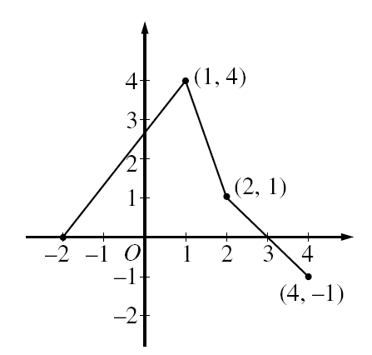

A) Find *g*(-2), *g*(3) and *g*(4).

B) On what intervals is *g* decreasing? Justify your answer.

C) Find the average rate of change of *g* on the interval 1 < *x* < 4. Show work that leads to

your answer.

D) Find the *x*-coordinate of each point of inflection of the graph of *g* on the interval

-2 < *x* < 4. On what interval(s) is the graph of *g* concave down? Justify your answers.